OVERVIEW 2022

Notes relating to forward-looking statements

This document contains statements about the future business development and strategic direction of the Company. The forward-looking statements are based on management's current expectations and assumptions. They are subject to certain risks and fluctuations as described in other publications, in particular in the risk and opportunities management section of the combined management report. If these expectations and assumptions do not apply or if unforeseen risks arise, the actual course of business may differ significantly from the expected developments. We therefore assume no liability for the accuracy of these forecasts.

These sections contain content or cross-references not required by law, which were not audited by the auditor, but were merely read critically. In the case of cross- references, the information to which the cross- references refer was also not audited.

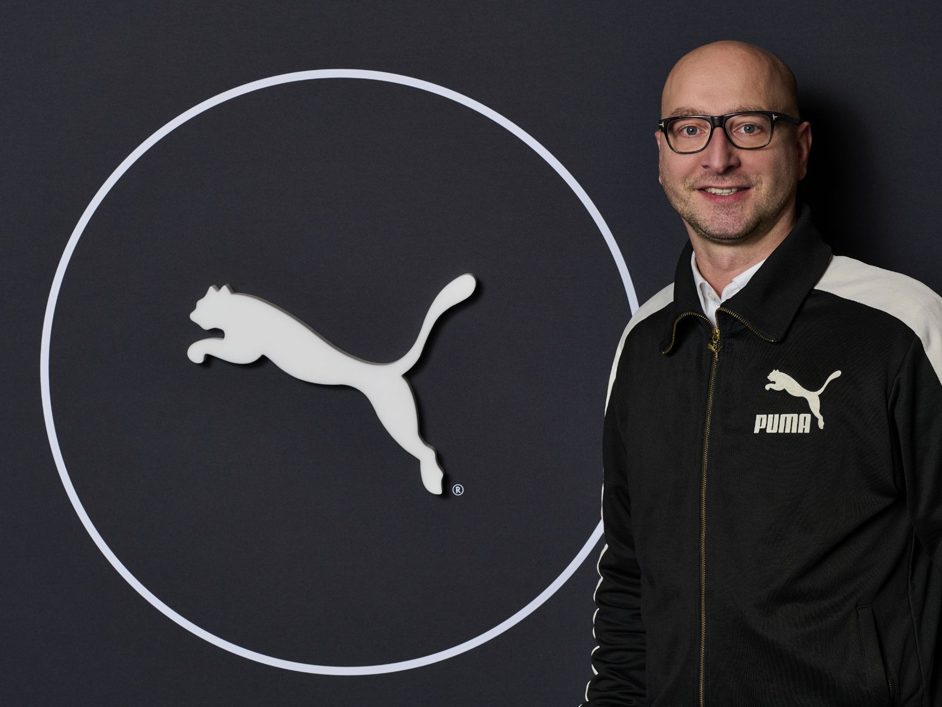

HUBERT HINTERSEHER

CHIEF FINANCIAL OFFICER PUMA

In 2022, the ongoing COVID-19 pandemic and the war in Ukraine required PUMA to be flexible and pragmatic. The health and safety of our PUMA Family was our top priority, while we executed our strategy to become the world’s fastest sports brand and continued our strong growth momentum.

From the outset of the war in Ukraine, we focused on our employees, athletes and other partners, providing safe accommodation and welcoming many PUMA employees and their families in Germany and Poland, where we also helped arranging work permits and jobs.

We were impressed by the actions taken by our PUMA Family. Colleagues in Poland and Hungary waited at the borders to bring PUMA employees and ambassadors from Ukraine to safety. Others from our HQ in Herzogenaurach drove to Ukraine to

bring necessities such as food and clothes to help those who had stayed in the country. We also gathered product donations for aid organizations in Ukraine to get help to those who needed it most.

For our efforts to provide an attractive workplace, PUMA was named a Top Employer 2022 in several regions of the world, including Europe and Asia/Pacific. We were listed by Forbes among the World’s Best Employers and by the Financial Times as a Leader in Diversity for Europe. In Germany, we were named “Company of the Year” at the German Diversity Awards and in Mexico we were among the best places to work for women in Expansión’s ranking “Súper Empresas Para Mujeres”.

The COVID-19 pandemic eased in Europe and the Americas, but the situation for our store network and our supply chain remained challenging in parts of Asia, especially in China, where our employees did an exceptional job despite the repeated lockdowns. The tireless work of our sourcing teams ensured that supply chain disruptions were kept to a minimum throughout the year.

PUMA’s brand heat was boosted further by the great performances of our athletes, who underscored our credibility as a sports brand. At the World Athletics Championships in Eugene, Oregon, USA, Jamaican sprinter Shericka Jackson ran the second fastest 200m time in history, while Swedish pole vaulter Armand “Mondo” Duplantis set yet another world record of 6.21 meters and was named “World Athlete of the Year.” Another gold went to Portuguese athlete Pedro Pichardo in the triple jump with the best performance of the year.

Our Ukrainian PUMA athlete Yaroslava Mahuchikh won the gold in the high jump at the World Indoor Championships in Belgrade, Serbia and the European Championships in Munich, Germany. Her win in Belgrade was a very emotional moment, after she took a difficult three-day journey by car at the start of the war in Ukraine to travel to the event in Serbia.

Our athletes relied on the latest versions of our evoSPEED NITRO spikes, which are made with PUMA’s NITRO-Technology and a PWRPLATE for extraordinary energy return. NITRO is also an important part of our newest product line-up for long- distance and road running, such as the futuristic FAST-R NITRO Elite and the DEVIATE NITRO ELITE 2.

We also added to our roster of international top athletes in road running, by signing Norwegian Sondre Moen and US athlete Jenny Simpson.

In Football, our PUMA Team Morocco sensationally reached the semifinal of the World Cup in Qatar. Our players Antoine Griezmann, Olivier Giroud and Raphaël

Varane were in the French starting line-up in the final. Neymar Jr. scored his 77th goal for the Brazilian national team, equaling the record of football icon Pelé.

Ahead of the tournament, we kicked off the “Generation Fearless” campaign, as part of which our global teamsport ambassadors presented our new ULTRA and the FUTURE 1.4 football boots.

The Women’s Euro in England confirmed the increasing popularity of women’s football in all markets. With Austria, Iceland, Italy and Switzerland, PUMA had four teams at the tournament and also generated great visibility with the more than 70 players who played in our boots. We equipped our players and teams with special collections and supported them with marketing campaigns ahead of the tournament.

Among club teams, PUMA teams AC Milan and Manchester City both won the title and Olympique de Marseille and Borussia Dortmund came in second in their respective leagues. In the Netherlands, PSV Eindhoven won the Dutch Cup. At the end of the season, PUMA secured a long-term contract extension with AC Milan and became the official match ball provider of the Italian football league Serie A, starting from the 2022/23 season.

In North America, PUMA works with LaMelo Ball, one of the most successful players in the NBA, and we created the very successful signature shoes MB.01 and MB.02 with him, which are sold exclusively at our strategic retail partner Foot Locker. Our basketball athlete Marcus Smart was named NBA Defensive Player of the Year while Jackie Young became the most improved player of the year in the WNBA. We expanded our roster of Basketball ambassadors with new signings such as Mikey Williams, Scoot Henderson and NaLyssa Smith.

In Golf, Cobra PUMA Golf athlete Ewen Ferguson won the Commercial Bank Qatar Masters and the ISPS Handa World Invitational, while Olivia Cowan claimed her maiden Ladies European Tour Victory in India at the Hero Women’s Open. Lexi Thompson took the trophy at the Aramaco series in NYC and once again joined the champions circle. Anna Nordqvist won in the The Netherlands and brought home the Big Green Egg Open. Finally, Justin Suh took his first win at the Korn Ferry Tour Championship, which paved his way onto the PGA Tour and gives him a spot in 2023 at The Players Championship and at the US Open.

In Motorsport, Red Bull Racing driver Max Verstappen secured another Formula 1 Drivers’ Championship, as PUMA supplied the three most successful teams in the sport: Scuderia Ferrari, Oracle Red Bull Racing and Mercedes-AMG Petronas F1. We benefited from the increasing popularity of the sport, especially in the United

States, where Miami hosted its first Grand Prix in 2022, which was immediately sold out.

During our return to New York Fashion Week, our spectacular FUTROGRADE show included a digital Web3 experience. The runway show was curated by PUMA Creative Director June Ambrose and special appearances on the catwalk by our ambassadors such as Usain Bolt, Winnie Harlow and Yaroslava Mahuchikh created a lot of buzz in the press and on social media. With the FUTROGRADE event, we showed that the virtual world is becoming increasingly relevant for our young audience.

In 2022, we also unveiled our largest Web3 collaboration to date with 10KTF and launched “PUMA and the Land of Games” on the online gaming platform Roblox. We used the Roblox experience for a unique launch event, as we first presented Manchester City’s new third kit in “PUMA and the Land of Games”, giving players the first opportunity to explore and interact with the new kit in the virtual world.

In 2022, we launched our PUMA Shopping App in India, the United States, the UK and Japan. The app allows consumers to virtually try on selected products before they buy, see what the products look like in sophisticated 3D animations and make purchases. PUMA further strengthened its distribution by entering new markets with the PUMA.com online store in the Philippines, Thailand, Peru, Norway, Saudi Arabia and several other new countries in the Middle East and Africa.

We announced a long-term partnership with British-Nigerian rapper, and record producer Skepta, who will design product and be a part of global marketing campaigns. Deals with pop stars Eleni Foureira from Greece and Teodora from Serbia underlined our focus on local relevance to reach audiences around the world.

In September, we invited industry peers, activists, NGOs, experts, ambassadors, and consumers to London for our sustainability event Conference of the People, an open conversation about sustainability, which put the concerns of Gen Z at the center of the debate. It gave us the opportunity to explain our sustainability work in great detail, including the RE:SUEDE and RE:JERSEY circularity projects. For RE:SUEDE, we distributed 500 experimental pairs of our iconic SUEDE sneaker to consumers in Germany, who tested them for half a year before returning them, so we can establish whether the sneakers can be biodegraded in a controlled industrial setting. The RE:JERSEY recycling project was unveiled in partnership with our football teams Manchester City, AC Milan, Borussia Dortmund, Olympique de Marseille and Girona. In this project, we trial a chemical recycling process,

which can turn old polyester garments into new polyester yarn and even deal with logos, embroideries and club badges. We expect to scale up the use of this chemical recycling process in the coming years.

Given our sustainability efforts, we were honored when industry publication Business of Fashion named PUMA the most sustainable brand in a ranking of the 30 largest companies in the business and when we received the Footwear News Sustainability Leadership Award. These awards are an important confirmation for us that we are on the right track and are making progress with our strategy to make PUMA more sustainable.

In November the Supervisory Board appointed Arne Freundt to become the chairman of the management board and CEO of PUMA SE. Arne Freundt has worked for PUMA for more than ten years, previously as a member of the Management Board and Chief Commercial Officer. He replaced Bjørn Gulden, who left the company after nine years.

In April, the Supervisory Board elected Héloïse Temple-Boyer as Chair of the Supervisory Board at its meeting. Héloïse Temple-Boyer has been a member of the Board since 2019 and is a member of the Audit Committee.

The financial year 2022 was marked by operational challenges due to the continued effects of the COVID-19 pandemic and the effects of the Russian invasion of Ukraine. The negative impact of the pandemic in the form of lockdown measures was particularly evident in Greater China, where retail shops had to be temporarily closed. Global goods availability improved significantly due to easing capacity bottlenecks in the logistics industry towards the end of the year.

Russia's invasion of Ukraine led to a significant impairment of business in these two countries in the past financial year 2022. At the beginning of the invasion, we suspended all of our retail activities in Russia and Ukraine. As a result, no sales were generated with the respective retail activities, but costs continued to be incurred. In Russia, retail activities remained suspended for the rest of the year. In Ukraine, we were able to resume most of our retail activities over the course of the year on the initiative of the Ukrainian team. Russia and Ukraine’s share of the total sales of the PUMA Group declined from almost 4% in the previous year and was then only 2% in 2022. At the end of the year, retail stores in Russia incurred impairment losses on rights-of-use in the amount of a high single-digit million euro figure. Due to the current situation, our retail activities in Russia remain suspended until further notice. The management team are carefully monitoring the current situation in Russia and analyzing the various possible scenarios and

measures. In all our considerations, the health and safety of our employees and their families are always our top priority.

Despite the uncertain geopolitical and macroeconomic business environment and the continuing negative impact of the COVID-19 pandemic, 2022 was the most successful financial year ever in the history of PUMA. Based on continued brand dynamics, successful product launches, the best possible service for our retail partners, athletes and consumers and a strong focus on flexibility in business operations, PUMA achieved record sales, operating result (EBIT) and consolidated net earnings in the past financial year.

The ongoing restrictions in connection with the COVID-19 pandemic in the Asian markets, especially in Greater China, the crisis in Ukraine and persistently high inflation had a negative impact on consumer confidence and demand in 2022.

Nevertheless, in the past financial year 2022, PUMA managed to exceed € 8 billion in sales for the first time in the company's history. Currency-adjusted sales increased by 18.9%. In the reporting currency, the euro, this corresponds to an increase in sales of 24.4% from € 6,805 million in the previous year to

€ 8,465 million in 2022. In the financial year 2022, PUMA thus managed to surpass the sales forecast for currency-adjusted sales growth in the mid-teen percent range, which had already been adjusted upward during the year.

Higher sourcing prices due to raw materials and cost increases for incoming freight, an unfavorable regional and distribution channel mix and increased promotional activities due to the promotional market environment led to a decline in the gross profit margin from 47.9% in the previous year to 46.1% in 2022. These negative effects were partially offset by price adjustments and currency effects. Net expenses from other operating income and expenses increased by a total of 21.0% in the 2022 financial year from € 2,725 million in the previous year to

€ 3,296 million. The increase was mainly due to higher expenses for marketing, a higher number of the Group’s own retail stores and higher sales-related distribution and warehousing costs. In addition, PUMA continued to be faced with operational inefficiencies, particularly in the supply chain, due to COVID-19. The weaker increase in other operating income and expenses compared to sales growth reflects the operating leverage achieved. As a result of continued cost control, it was possible to achieve a reduction in the cost ratio from 40.0% in the previous year to 38.9% in 2022.

Due to the strong sales growth and continued cost control, the operating result (EBIT) increased by 15.0% in the past financial year from € 557.1 million to

€ 640.6 million. The operating result therefore lies within the forecast of a range between € 600 million and € 700 million. However, the EBIT margin decreased from

8.2% in the previous year to 7.6% in 2022. The improvement in operating result is also reflected in the development of consolidated net earnings, which improved by 14.2% year-on-year. Consolidated net earnings increased from € 309.6 million in the previous year to € 353.5 million, while earnings per share rose accordingly from

€ 2.07 in the previous year to € 2.36. This allowed PUMA to achieve record consolidated net earnings in the financial year 2022 and fully achieve the profitability targets in the past financial year.

The positive net earnings enables the Management Board and the Supervisory Board to propose the distribution of a dividend of € 0.82 per share for the financial year 2022 at the Annual General Meeting on May 24, 2023 via corresponding distributions and profit transfers to PUMA SE. This corresponds to a payout ratio of 34.7% of consolidated net earnings according to IFRS and is in accordance with PUMA's dividend policy, which foresees a payout ratio of 25% to 35% of consolidated net earnings. In the previous year, a dividend of € 0.72 per share was paid out (payout ratio for previous year: 34.8%).

As part of the quarterly index review, the PUMA share has been relisted on the MDAX stock exchange index since December 2022. The PUMA share was previously a member of the DAX since September 2021. After starting 2022 at a price of

€ 107.50, PUMA's share price fell to a low of € 43.85 in October 2022. The price of the PUMA share then recovered by the end of the year and rose to € 56.70. This represents a decline in the share price of 47.2% compared with the previous year. The market capitalization of the PUMA Group amounted to around € 8.5 billion at year-end 2022 (previous year: € 16.1 billion).